Task

You have been tasked to construct a proposal/specification for a project. The topic of your proposal is up to you (although a default is provided below).

## Your proposal/specification must include at the minimum:

* A high-level description of your project
* A report intended audience and use
* You must include sketches if your project is interactable in digital or physical space.
  + Sketches will imply how a product will look like when it is finished
  + How it is used
  + How it is put together (if applicable)
* Lightweight process diagramming (boxes and arrows) of how the critical parts of your project will work
* Project Story Cards of your project
* Story Cards should be quoted for Must | Should | Could have
* You do not have to quote time to complete or complexity

## Project Proposal

You can choose to build any project. However, you are greatly restricted on time and resources. Resources may be able to be acquired, but due to covid/global shortages/etc., this is not dependable. Time is limited, as semester finishes early, and we have 3 hours 40 minutes each week.

Your project must be a small series of mechatronic systems. Each system includes sensors, actuators, physical models, and have some sort of intended interaction. In addition, the system’s intended interaction must be driven by decoupled serial events. These serial events will come from a third party service (raspberry pis). This process will be provided as a library.

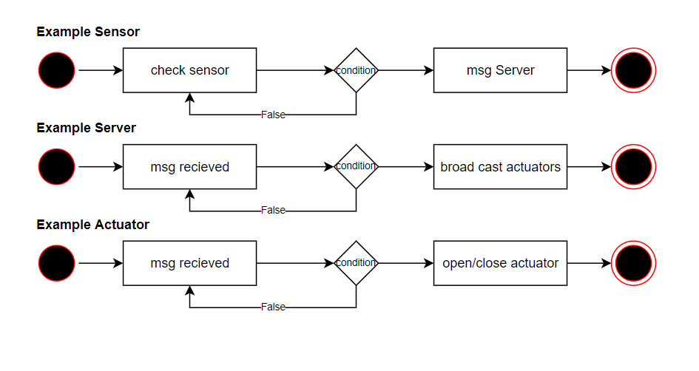

The default example for this project is constructing a part of the Cyber Range City (Arduino City). An example of a feature of Arduino City might be a draw bridge that opens when a “boat” gets too close and closes the road for safety purposes.

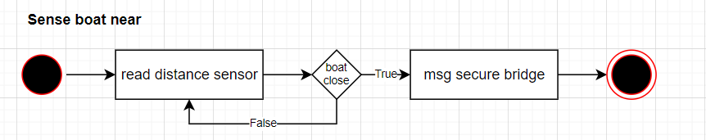

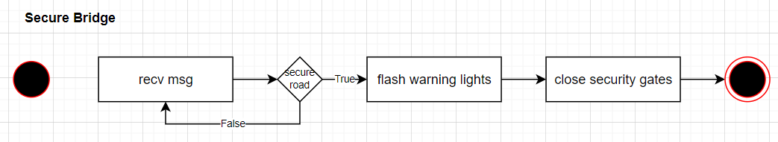

etc

## Submission Guide

### Learning tasks

At the minimum:

* A specification document
* Feel free to add anything else you want

### Learning deliverables

* A short description of your project.
* A description of the indented audience and use
* Sketches/Process diagramming
* Story Cards

## Rubric

|  |  |  |  |  |  |  |
| --- | --- | --- | --- | --- | --- | --- |
|  | **Knowledge, Comprehension & Application** |  |  |  |  |  |
| **CRITERIA** | **EXPECTATIONS** | **POSS** | **STUDENT** | **GIVEN** | **MULTI** | **TOTAL** |
| **Project Descriptions**  (individual) | You have provided **evidence of producing project descriptions**. The project descriptions appear to be **a serious attempt** and look like they meet the overall goals of **rigour and suitability**.   * A high-level description of the project * A description of who will use your product and how it will be used or why your system exists and how it works.   Evidence for knowledge, comprehension, and application may include:   * **Knowledge**: Your evidence highlights that you recall and list relevant terms in your learning. It may tell a story to the reader (the teacher) or state the conditions of your learning. * **Comprehension**: Your evidence highlights that you can identify critical aspects of your learning or explain what you've done to the author. * **Application**: It is clear from your evidence that you constructed a complete submission | 2  2 | __/2  __/2 | __/2  __/2 | - | __/ 4 |
| **Lightweight Prototyping | Modelling**  (individual) | You have submitted relevant **lightweight prototypes and/or models** of your system or solution.  Your prototypes/models **appear to describe** how your solution will be put together, how it will be used, and as a high-level overview of the system.   * Modelling/prototyping of how your system will be put together * Modelling/prototype of how your system will be used * Modelling/prototyping which provides a high-level overview of your system   Evidence for knowledge, comprehension, and application may include:   * **Knowledge**: Your evidence highlights that you recall and list relevant terms in your learning. It may tell a story to the reader (the teacher) or state the conditions of your learning. * **Comprehension**: Your evidence highlights that you can identify critical aspects of your learning or explain what you've done to the author. * **Application**: It is clear from your evidence that you constructed a complete submission   Note: the assessor may use their discretion to source other evidence from this assessment to judge the activity if required. | 2  2  2 | __/2  __/2  __/2 | __/2  __/2  __/2 | A x2  T x1 | A __/ 12 T __/ 6 |
| **Story Cards**  (individual) | You have submitted **evidence of story cards**. The story cards appear to **describe the abstracted parts of your project** from a management point of view and **highlights such things as the minimal viable product**.   * Project Story Cards which provide a high level overview of your system * Project Story Cards of how your system will be put together * Project Story Cards of how your system will be used   Evidence for knowledge, comprehension, and application may include:   * **Knowledge**: Your evidence highlights that you recall and list relevant terms in your learning. It may tell a story to the reader (the teacher) or state the conditions of your learning. * **Comprehension**: Your evidence highlights that you can identify critical aspects of your learning or explain what you've done to the author. * **Application**: It is clear from your evidence that you constructed a complete submission   Note: the assessor may use their discretion to source other evidence from this assessment to judge the activity if required. | 2  2  2 | __/2  __/2  __/2 | __/2  __/2  __/2 | A x2  T x1 | A __/ 12 T __/ 6 |
|  | **Analysis, Synthesis & Evaluation** |  | | **SUB TOTAL** | | **A _ / 28**  **T _ / 22** |
| **Written Specification**  **Communication** | The evidence that you have submitted highlights your ability to communicate with technical experts to describe who the product is for or how it interacts with the broader system.  The written descriptions highlight your understanding of the initial stages of our design processes and the initial requirements.  Each of your questions will be marked against the following aspects of your ability to:   * your understanding of technology concepts and principles and how it relates to projects * your ability to communicate ideas appropriately in the selected medium   Evidence for higher-order learning may include:   * **Analysis**: Your evidence shows a reasoned understanding of what you did and why. For example, you may have explained how you did X, Y, and Z, but you continue to explain why you did them the way you did. * **Evaluative**: your evidence makes a judgement of something or between multiple things. This judgement may be the value of one thing over another or highlighting the significant differences between two things. * **Transferal**: your evidence highlights when you apply information, strategies, or skills that you have learnt to a new situation or context.   Note: the assessor may use their discretion to source other evidence from this assessment to judge the activity if required. | 4  4 | __/4 __/4 | __/4 __/4 | - | __/ 8 |
| **Visual Specification Documentation** | The evidence of the lightweight prototyping that you submitted highlights your ability to communicate your system(s) visually. They describe how the product is intended to be used, a high level of visual explanation.  The visual specification highlights your understanding of explaining your descriptions visually.  Each of your questions will be marked against the following aspects of your ability to:   * your understanding of technology concepts and principles in related to projects * your ability to communicate ideas appropriately in the selected medium   Evidence for higher-order learning may include:   * **Analysis**: Your evidence shows a reasoned understanding of what you did and why. For example, you may have explained how you did X, Y, and Z, but you continue to explain why you did them the way you did. * **Evaluative**: your evidence makes a judgement of something or between multiple things. This judgement may be the value of one thing over another or highlighting the significant differences between two things. * **Transferal**: your evidence highlights when you apply information, strategies, or skills that you have learnt to a new situation or context.   Note: the assessor may use their discretion to source other evidence from this assessment to judge the activity if required. | 4  4 | __/4 __/4 | __/4 __/4 | - | __/ 8 |
| **Incorporation of written and visual communication strategies into initial Project Management** | The evidence of the Project Collaboration Cards highlights your ability to incorporate your written and visual communication of your system into the suitability of your initial project management processes.  Your Project Collaboration Cards highlight the different abstracted tasks that need to be completed and the must | should | could have of each task.  Each of your questions will be marked against the following aspects of your ability to:   * your understanding of technology concepts and principles for projects * your ability to communicate ideas appropriately in the selected medium   Evidence for higher-order learning may include:   * **Analysis**: Your evidence shows a reasoned understanding of what you did and why. For example, you may have explained how you did X, Y, and Z, but you continue to explain why you did them the way you did. * **Evaluative**: your evidence makes a judgement of something or between multiple things. This judgement may be the value of one thing over another or highlighting the significant differences between two things. * **Transferal**: your evidence highlights when you apply information, strategies, or skills that you have learnt to a new situation or context.   Note: the assessor may use their discretion to source other evidence from this assessment to judge the activity if required. | 4  4 | __/4 __/4 | __/4 __/4 | A x1  T x 2 | A __/ 8  T __/16 |
|  | **Submission Guidelines** |  | | **SUB TOTAL** | | **A __/24**  **T __/48** |
| **Quality of Submission** | **Assessment submission is ordered** and has a definite pattern to its construction. **The reader is not confused about the content in any given section and can follow the submission flow** easily. | 4 | __/4 | __/4 | x2 | __ / 8 |
| **Formatting** | **Students have** **followed the formatting instructions,** including any provided templates and guides **or have created their own** legible formatting guide **and applied it constantly**. | 2 | __/2 | __/2 | - | __ / 2 |
|  |  |  | | **SUB TOTAL** | | **__ /10** |
|  | DAYS LATE ___/7 = ___% |  |  | **FINAL** | | **A __/XX T __/XX** |

## Rubric sections

##### Section 1: Knowledge Comprehension and Application

This section of the rubric consists of the required elements of the assignment. Students should take special care to include ALL these elements as they are often extended in the following sections

##### Section 2: Analysis, Synthesis, and Evaluation.

This section will evaluate your ability to include critical thinking and justification elements into your work. Often the requirements for extension are not explicitly given, so it will be up to you to decide how best to demonstrate what you have learned beyond the required unit goals and curriculum. Items such as 3D models, pictures, drawings, diagrammatic responses, notes, evidence of problem-solving, advanced programming concepts, elegant responses, media, etc., are all available options.

##### Section 3: Submission Guidelines

Students are expected to provide a submission that fulfils the requirements listed in style guides while also submitting at an appropriate quality. Be aware that points in this section could be 2- or 4-point items. Treat them accordingly.

## Submission

All submission items should be stored in an appropriate format. For example, code must be stored in a programmatical format so it can be evaluated (**images of code or code copied and pasted into a document may not be marked**)

Evidence of working material must be recorded where appropriate. For example, to show how your robot meets a requirement, you must submit a recording of it completing that requirement. Similarly, if you need to show how your program can download a file from the internet and crack a password, you must submit a recording of it doing that.

Ask the teacher if you are unsure if an element needs to be recorded**.**

All materials must be submitted to Google Classroom.

Students are responsible for keeping backups/master copies.

## **Scoring Notes**

Formatting for all typed/written assessments should be as follows:

|  |  |  |  |  |  |  |
| --- | --- | --- | --- | --- | --- | --- |
| **Google Doc** | 11-12 Pt | 1.15-1.5 Line Spacing | 1 Space between paragraphs | Spelling and Grammar “Soft Limit” | In-Text Citations with footnotes | Title Page/Slide:   * Name * Date * Class * Aim * Assessment title |
| **Slides** | 10-12 pt. font text  14-24 pt. font titles | 1.0 1.15 Line Spacing | Bullet Points Preferred | Word Count per slide >100-110 “Soft Limit.” | Approved Templates and Themes |
| **Python** | We apply the following style guide to Python files. However, in general, most programs follow this overall layout.    [PEP 8: The Style Guide for Python Code](https://pep8.org/) | | | | | |
| **Arduino**  **C/C++** | We apply the following style guide to C/C++ files. However, in general most programs follow this broad layout.    I accept both K&R and K&R alternative bracing format. As long as it is consistent in your file.  [Arduino Style Guide for Creating Libraries | Arduino Documentation | Arduino Documentation](https://docs.arduino.cc/learn/contributions/arduino-library-style-guide) | | | | | |
| **Markdown** | We apply the following style guide to markdown documents. However, in general, most documents follow some variation of the following layout:    <https://github.com/google/styleguide/blob/gh-pages/docguide/style.md> | | | | | |

“Soft Limits” are not rigidly defined limits and will be assessed on a case-by-case basis. Ask for clarification on specific tasks

## Possible Scoring Groups are out of 2 or 4 Points.

##### 2-Point Criteria - Knowledge and Understanding

Criteria assessed as 2-Points are classified as Knowledge and Understanding criteria. These will examine and evaluate a student’s ability to effectively state facts and define terms and concepts. Analysis and synthesis of the information will not be assessed through these criteria.

|  |  |  |  |
| --- | --- | --- | --- |
|  | **0 Points** | **1 Point** | **2 Points** |
| **2 Point Criteria** | **Not present** or **not able to be assessed** as the required criteria | Item is presented but **does not meet expectations** for quality, rigour, or detail. | Item is presented and **does meet expectations** for quality, rigour, or detail |

##### 4-Point Criteria - Analysis and Synthesis and Expert Review

To show true mastery of your developing skills, students must show that they can go beyond simple repetition of the given tasks or an explanation of processes. Students will demonstrate their ability to show higher-order thinking through analysis, evaluation, or linking multiple fields of learning to solve problems in novel ways.

## Analysis and Synthesis

Analysis and Synthesis components evaluate a student’s ability to effectively review data and understandings and develop these into a coherent and relevant statement. Analysis refers to the generating of thoughts from interpreting the data. In contrast, synthesis combines experience from one area with other pertinent knowledge to develop an original and compelling solution.

|  |  |  |  |  |  |
| --- | --- | --- | --- | --- | --- |
|  | **0 Points** | **1 Point** | **2 Points** | **3 Points** | **4 Points** |
| **4 Point Criteria** | **Not present** or **not able to be assessed** as the required criteria | Evidence is presented and explained. However, it **does not show appropriate evidence of higher-order thinking** such as analysis, evaluation, or synthesis. | Evidence is presented and **shows appropriate evidence of higher-order thinking** such as analysis, evaluation, or synthesis. | Evidence is presented and **exceeds expectations for evidence of higher-order thinking** such as analysis, evaluation, or synthesis.  **-or-**  Item is presented and shows appropriate evidence of higher-order thinking such as analysis, evaluation, or synthesis and **exceeds expectations for quality or rigour** of understanding of the selected mastery. | Evidence is presented and **exceeds expectations for evidence of higher-order thinking** such as analysis, evaluation, or synthesis. **Additionally, this item exceeds expectations for quality or rigour** of understanding of the selected mastery. |

##### Expert Review

Expert Reviews evaluate a student’s ability to build solutions using the skills taught during the semester. Criteria assessed as 4-Points are classified as Analysis and Synthesis criteria. These will examine and evaluate a student’s ability to effectively review data and understandings and develop these into a coherent and relevant statement. Analysis refers to the generating of thoughts from interpreting the data. In contrast, synthesis combines experience from one area with other pertinent knowledge to develop an original and compelling solution.

|  |  |  |  |  |  |
| --- | --- | --- | --- | --- | --- |
|  | **0 Points** | **1 Point** | **2 Points** | **3 Points** | **4 Points** |
| **4 Point Criteria** | **Not present** or **not able to be assessed** as the required criteria | Evidence is presented and broadly solves the problem. However**, the evidence does not show appropriate mastery** upon review. | Evidence is presented and broadly solves the problem. On review, it **does show appropriate evidence** of mastery. | Evidence is presented and solves the specific problem. On review, the evidence **shows understanding beyond expected mastery**.  **-or-**  Item is presented and broadly solves the problem. On review, it does show appropriate evidence of mastery and is **done so in a well-constructed or design method** that clearly shows higher levels of understanding**.** | Evidence is presented and solves the specific problem. On review, **the evidence shows understanding well beyond expected mastery** and is **done so in a well-constructed or designed method** that clearly indicates higher levels of understanding. |

##### Multiplier

Criteria will be combined with a **Multiplier**. While each criterion will be scored on the 0-1-2-4 scale, the multiplier will attach relevant worth to each criterion. Be aware of these multipliers and dedicate appropriate time to ensure you achieve your best result.

## Achievement Standards:

## Evidence of higher-order learning:

What is it that I mean by “higher-order thinking”?

It means I want you to go beyond replicating what we do in class. I want you to dig into your brain and understand why you did something, what about it was great, and what could be improved.

Why is this important? Reflective thinkers can go beyond what they are taught and can customise their learning to ben

